Managing Change

Road Map for Change

An EPIC!
Creating a road map for change involves outlining clear phases, and actions within each phase, to guide the process effectively.

A simple framework for a road map can be remembered using the acronym ‘An EPIC’:

An | Analyse
E | Engage
P | Prepare
I | Implement
C | Consolidate

Here is a reminder of some of the key things you’ll need to consider at each phase and the actions that need to be taken.

Analyse | This phase is all about understanding the need for change and what it is intended to achieve.  Actions will include:  - Clarifying the need.  - Establishing key measurable objectives/goals.  - Making sure these align with the organisation’s goals, values and mission/vision.  - Identifying key stakeholders and engaging with them.  - Evaluating the capacity for change, including resources, people and culture.  - Assessing the impact of what’s happening elsewhere.  - Assessing the external impact of the change.

Engage | This phase is all about building awareness and support for the project.  Actions will include:  - Selling the idea/change to key stakeholders by highlighting the rationale and benefits.  - Working with stakeholders to ensure there is buy-in and engagement.  - Listening to feedback and addressing concerns.
Prepare | This phase is all about preparing for implementation.  Actions will include:  - Creating a detailed step-by-step plan for the implementation with reference to people, resources, timelines and roles.  - Establishing clear milestones and review points.  - Identifying the risks and planning how to eliminate, mitigate or manage these.  - Ensuring key people and skills are in place (for example through recruitment or training).  - Creating a detailed communication plan, using multiple channels to build and maintain, awareness, motivation, momentum and engagement throughout the project.
Implement | Specific steps, checks and measures here will help ensure success.  Actions will include:  - Piloting methodologies, solutions, ideas and evaluating their success before rolling out.  - Rolling out the programme of implementation using the detailed plan.  - Listening to concerns and feedback and responding.  - Monitoring progress, learning and adapting plans.  - Providing support through ongoing training, resources and guidance.  - Celebrating milestones.  - Renewing the focus on engagement.

Consolidate | This phase is all about ensuring the change is sustained, reinforced and that the long-term goals are achieved.  Actions will include:  - Reviewing what went well, what didn’t go well and what can be learnt from the experience.  - Celebrating the achievement.  - Recognising and rewarding success.  - Taking practical steps to embed the change in the organisation’s culture and operations.  - Monitoring improvements and measuring the impact of the change.  - Identifying, and encouraging others to identify, opportunities for further/continuous improvement.

Notes:

Dinner Party
Mayhem

What were the key lessons about leading change?

What were the key lessons about how people react to change?

What were the key lessons for me?

A study by Professor Nutt of Ohio State University into Change Implementation in 376 change initiatives identified four change agent styles. In the following diagram, 1 represents most used/successful approach, 4 represents the least used/successful approach.

 |  | Usage | Success
Tell | “This is what I’ve decided will happen.” | 2 | 4
Sell | As above, plus, “this is why.” | 1 | 3
Persuade | “Give me some alternatives.” | 3 | 2
Engage | “What do we think?” | 4 | 1

Notes:

Beastly Barbecues

Record any good ideas from the other teams in the spaces below, as well as questions you’d like to ask them:

Persuading Others that Change is Necessary:
Good ideas:

Questions:

Creating a Vision:
Good ideas:

Questions:

Empowering People:
Good ideas:

Questions:

Establishing Goals and

Maintaining Momentum:
Good ideas:

Questions:

Learning Points
1
2
3
4
5
6
7
8
9
10

Maintaining Momentum

One of the key skills that great project managers possess is the ability to keep the momentum within a project. When an idea is first discussed there is usually a great deal of enthusiasm for it, particularly from those who generated the idea. However, that enthusiasm can quickly wane if the new idea appears to simply generate more work and new problems.

Without a sense of momentum, or individuals’ enthusiasm, projects can get bogged down and eventually grind to a halt. It’s a bit like trying to push a snowball uphill.

In contrast, when people retain a sense of excitement about a project, you may be able to build momentum so that progress begins to feel unstoppable: A bit like rolling a snowball downhill!

So, what can you do to maintain and build a sense of momentum within projects? Record your key learning points below:

Learning Points
1
2
3
4
5
6
7
8

Passengers
- A Change Journey

Reluctant Passengers:
Reluctant passengers are those who think they’d be a better driver, than the current one, which might be you. It can be difficult be a reluctant passenger and it can be difficult to have reluctant passengers on the journey with you.

Think about a change where you’ve had reluctant passengers on your team, or where you’ve been a reluctant passenger. Reflect on the following questions and record any thoughts and ideas you have. Consider how you felt in the situation but consider too how it felt for the other person. (In other words, whichever position you were in, try to record some thoughts in both columns.)

 | Driver | Reluctant Passenger
Which were you?
How did it feel to be in this situation?

 | Driver | Reluctant Passenger
How might the situation have impacted your behaviour and the behaviour of the other person?
What could you have done differently to make the journey easier?

 | Driver | Reluctant Passenger
What did you learn from the journey?

Notes:

Passengers - Action Plan
This is your opportunity to reflect on what you have be learning and identify the actions you need to take to successfully adapt your behaviour.

My Change:

Driver? | Front seat passengers?
Am I driving the change? If not, who is? What needs to be done to ensure a smooth journey for the other passengers? | Who has the best view of the road ahead? What is their role? What do they need and how can they support the driver?

Back seat passengers? | Hitchhikers?
Who are less involved but nevertheless coming on the journey? What do I need to do to engage them? What’s their role? How do I help to maximise their contribution? | Do I have any hitchhikers? People who are just along for the ride? Those who don’t know where we’re going and how it fits with their plans? What actions do I need to ensure we share the same destination? To what extent can I/should I engage them?

Reluctant Passengers?
Are there any reluctant passengers? What can we do to help prevent division between them and the driver?

Selling Change

Learning Points
1
2
3
4
5
6
7
8
9
10
11
12

The Royal Wedding Street Party

There is much rejoicing in the Kingdom of Bung with the happy news that the beautiful Princess Christina is to marry her handsome beau Gareth.

Born to humble parents in the small town of Bryn, Gareth has impressed his fellow citizens with his hard work, his discretion and, above all, his loyalty to Princess Christina and her father the king.

The wedding will be celebrated at the castle in the heart of the city of Glum. Many people are expected to go to the city to join in the celebrations, but far away, in Gareth’s hometown of Bryn, plans are underway for a street party of their very own to celebrate the nuptials between local-hero Gareth and Princess Christina.

The street party is the brainchild of a 12-year-old girl called Arwen, who is completely caught up in the romance of a princess getting married to a local boy. Her mother, Heddwyn, is proud of what her daughter is trying to achieve and has promised to help Arwen bring her dream to life.

Arwen’s vision is for a street party in the marketplace at the centre of the town. She is hoping to have big screens showing the wedding ceremony first before a traditional street party for 250 locals.

For it all to happen, the Mayor will need to give his permission. So far, he hasn’t been as excited as Arwen thought he would be; Heddwyn thinks this is because he’s going to the actual wedding as a VIP guest, so won’t be attending the street party.

More enthusiastic though are the local schools who have promised to make bunting and table decorations for the street party. In exchange, the pupils and their families will have their names put into a draw for 50 free tickets. The other 200 tickets will be sold in order to cover the costs of staging the party.

The local hotel (The Royal Flag) has agreed to provide the food as long as this gets mentioned in the local newspaper and they can put a banner up in the marketplace advertising this.

The wedding is actually taking place on a Tuesday, which is normally market day in Bryn. However, a national holiday has been called so the market has already been cancelled.

Arwen is also hoping to persuade some street entertainers to perform for free and as a big fan of candy floss and popcorn herself, she’s rather keen to see if a vendor can be found to supply such treats. Heddwyn has convinced her that people will need to pay extra for such treats.

The national newspaper, The Bung Times, has been following the story of Arwen’s plans and have included updates on her progress in their newspaper for the last three weeks. They have now offered to provide a bouncy castle and a bouncy slide all the way from Glum for guests to play on during the party in exchange for having exclusive coverage of the celebrations.

Such is the excitement that even the Town Crier wants to be involved now.

Consider the following potential stakeholders, where do they fit in the grid of people Arwen needs to influence?

Stakeholder | Influence on the success of the project |  |  |  |  |  |  |  |  |  | Interest in the success of the project
Heddwyn | 1 | 2 | 3 | 4 | 5 | 6 | 7 | 8 | 9 | 10 | 1 | 2 | 3 | 4 | 5 | 6 | 7 | 8 | 9 | 10
The Mayor | 1 | 2 | 3 | 4 | 5 | 6 | 7 | 8 | 9 | 10 | 1 | 2 | 3 | 4 | 5 | 6 | 7 | 8 | 9 | 10
Local Schools | 1 | 2 | 3 | 4 | 5 | 6 | 7 | 8 | 9 | 10 | 1 | 2 | 3 | 4 | 5 | 6 | 7 | 8 | 9 | 10
The citizens of Glum | 1 | 2 | 3 | 4 | 5 | 6 | 7 | 8 | 9 | 10 | 1 | 2 | 3 | 4 | 5 | 6 | 7 | 8 | 9 | 10
The citizens of Bryn | 1 | 2 | 3 | 4 | 5 | 6 | 7 | 8 | 9 | 10 | 1 | 2 | 3 | 4 | 5 | 6 | 7 | 8 | 9 | 10
Bryn market stall holders | 1 | 2 | 3 | 4 | 5 | 6 | 7 | 8 | 9 | 10 | 1 | 2 | 3 | 4 | 5 | 6 | 7 | 8 | 9 | 10
The Bung Times | 1 | 2 | 3 | 4 | 5 | 6 | 7 | 8 | 9 | 10 | 1 | 2 | 3 | 4 | 5 | 6 | 7 | 8 | 9 | 10
The Royal Flag Hotel | 1 | 2 | 3 | 4 | 5 | 6 | 7 | 8 | 9 | 10 | 1 | 2 | 3 | 4 | 5 | 6 | 7 | 8 | 9 | 10
The Town Crier | 1 | 2 | 3 | 4 | 5 | 6 | 7 | 8 | 9 | 10 | 1 | 2 | 3 | 4 | 5 | 6 | 7 | 8 | 9 | 10
Bouncy Castle and Slide Company | 1 | 2 | 3 | 4 | 5 | 6 | 7 | 8 | 9 | 10 | 1 | 2 | 3 | 4 | 5 | 6 | 7 | 8 | 9 | 10
Popcorn and Candy Floss vendor | 1 | 2 | 3 | 4 | 5 | 6 | 7 | 8 | 9 | 10 | 1 | 2 | 3 | 4 | 5 | 6 | 7 | 8 | 9 | 10

Which Quadrant?
Place Arwen’s stakeholders where they currently sit in the quadrants below:

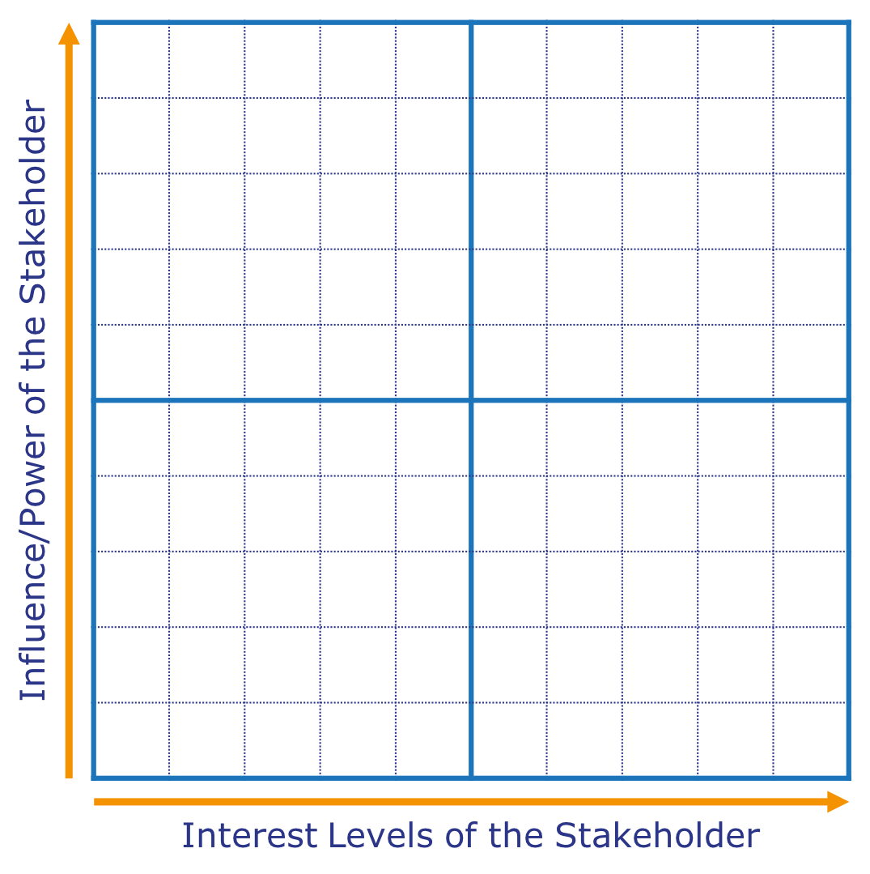

Are there any stakeholders that Arwen needs to try and move to a different quadrant?

Your Stakeholders

For each your stakeholders consider their:
- Influence they have on the successful outcome of your project.
- Interest in the successful delivery of the project.

For each stakeholder, please circle the score out of 10 that you would currently give them for their influence and interest.

Stakeholder | Influence on the success of the project |  |  |  |  |  |  |  |  |  | Interest in the success of the project
 | 1 | 2 | 3 | 4 | 5 | 6 | 7 | 8 | 9 | 10 | 1 | 2 | 3 | 4 | 5 | 6 | 7 | 8 | 9 | 10
 | 1 | 2 | 3 | 4 | 5 | 6 | 7 | 8 | 9 | 10 | 1 | 2 | 3 | 4 | 5 | 6 | 7 | 8 | 9 | 10
 | 1 | 2 | 3 | 4 | 5 | 6 | 7 | 8 | 9 | 10 | 1 | 2 | 3 | 4 | 5 | 6 | 7 | 8 | 9 | 10
 | 1 | 2 | 3 | 4 | 5 | 6 | 7 | 8 | 9 | 10 | 1 | 2 | 3 | 4 | 5 | 6 | 7 | 8 | 9 | 10
 | 1 | 2 | 3 | 4 | 5 | 6 | 7 | 8 | 9 | 10 | 1 | 2 | 3 | 4 | 5 | 6 | 7 | 8 | 9 | 10
 | 1 | 2 | 3 | 4 | 5 | 6 | 7 | 8 | 9 | 10 | 1 | 2 | 3 | 4 | 5 | 6 | 7 | 8 | 9 | 10
 | 1 | 2 | 3 | 4 | 5 | 6 | 7 | 8 | 9 | 10 | 1 | 2 | 3 | 4 | 5 | 6 | 7 | 8 | 9 | 10
 | 1 | 2 | 3 | 4 | 5 | 6 | 7 | 8 | 9 | 10 | 1 | 2 | 3 | 4 | 5 | 6 | 7 | 8 | 9 | 10
 | 1 | 2 | 3 | 4 | 5 | 6 | 7 | 8 | 9 | 10 | 1 | 2 | 3 | 4 | 5 | 6 | 7 | 8 | 9 | 10
 | 1 | 2 | 3 | 4 | 5 | 6 | 7 | 8 | 9 | 10 | 1 | 2 | 3 | 4 | 5 | 6 | 7 | 8 | 9 | 10
 | 1 | 2 | 3 | 4 | 5 | 6 | 7 | 8 | 9 | 10 | 1 | 2 | 3 | 4 | 5 | 6 | 7 | 8 | 9 | 10
 | 1 | 2 | 3 | 4 | 5 | 6 | 7 | 8 | 9 | 10 | 1 | 2 | 3 | 4 | 5 | 6 | 7 | 8 | 9 | 10
 | 1 | 2 | 3 | 4 | 5 | 6 | 7 | 8 | 9 | 10 | 1 | 2 | 3 | 4 | 5 | 6 | 7 | 8 | 9 | 10
 | 1 | 2 | 3 | 4 | 5 | 6 | 7 | 8 | 9 | 10 | 1 | 2 | 3 | 4 | 5 | 6 | 7 | 8 | 9 | 10
 | 1 | 2 | 3 | 4 | 5 | 6 | 7 | 8 | 9 | 10 | 1 | 2 | 3 | 4 | 5 | 6 | 7 | 8 | 9 | 10

Which Quadrant?
Place your stakeholders where they currently sit in the quadrants below:

Now consider if you could realistically shift any of your stakeholders towards the right (please note it would be rare, though not impossible, to be able to increase their influence).

Stakeholder Analysis

Reflect upon your stakeholders, how can you make them a positive influence on what you are trying to achieve?

Stakeholder | Quadrant |  | What do you need from the stakeholder | What matters to the stakeholder? | How could the stakeholder prevent success? | Plan for maximising stakeholder support

Action Plan

Reflect on what you’ve been learning. What actions do you need to take to successfully adapt your behaviour?

Goal | What action do I need to take? | Deadline | How will I know that I have succeeded? | What additional support do I need?

