From Team Member to Team Manager

Managing Challenges

Managing Challenges Action Plan

|  |  |  |  |
| --- | --- | --- | --- |
|  | **Goal:** | **Support Needed:** | **Resources:** |
| **Actions I need  to take with a  specific individual.** |  |  |  |
|  |  |  |
|  |  |  |

|  |  |  |  |
| --- | --- | --- | --- |
|  | **Goal:** | **Support needed:** | **Resources:** |
| **Actions I should take with my  team.** |  |  |  |
|  |  |  |
|  |  |  |

The Cracked Pot

The tale of The Cracked Pot is a great metaphor for the balancing act all managers face when managing the performance of their team. Listen to the start of the story and then in your teams consider the following:

|  |
| --- |
| How do you think the undamaged pot feels about the situation? |

|  |
| --- |
| How do you think the cracked pot feels about the situation? |

|  |
| --- |
| How do you think the water bearer feels about the situation? |

Triangle of Responsibility

The Planner

The Protector

The Provider

**The Planner**

Planning and controlling.

|  |
| --- |
|  |

**The Provider**

Information and materials needed.

|  |
| --- |
|  |

**The Protector**

Responsibility, security and motivation.

|  |
| --- |
|  |

Triangle of Responsibility

* Part 2

**My Planning Actions:**

|  |
| --- |
| Actions: |
| How will I achieve this, and when? |

**My Providing Actions:**

|  |
| --- |
| Actions: |
| How will I achieve this, and when? |

**My Protecting Actions:**

|  |
| --- |
| Actions: |
| How will I achieve this, and when? |

|  |
| --- |
| Notes: |

Getting Smart

Chris in IT

Chris works as part of an 18-person Helpdesk team, who assist staff members with any IT issues.

As a Level 1 Operator, his job is to handle basic IT queries and escalate more complicated or serious matters to the Level 2 Supervisors on shift. He must make sure he quickly and correctly identifies calls that need escalating and transfer them to the Level 2s.

On a normal 7-hour shift, Level 1s are expected to answer between 50 and 60 calls. Experience shows that to do this, virtually all calls need to be completed in under 10 minutes, but the majority need to be resolved much quicker.

If it’s a software issue, Level 1s should be able to resolve it remotely. Where there’s a problem with the hardware, new parts need to be ordered. To keep downtime to a minimum, the department standard is for new parts to be ordered on the day the problem is identified.

The helpdesk operates 24 hours a day and the shifts are strictly worked out to ensure phone cover is available continuously, so prompt time keeping is required. All Level 1s and 2s are expected to be taking calls from the start of their shift.

After a call has been resolved, the staff member who raised the issue is asked to rate the quality of the response they received. A monthly ‘approval rating’ is then generated for each member of the helpdesk team.

***Your task is to work together in your team to write five SMART objectives for Chris.***

|  |  |
| --- | --- |
| **Identify Five SMART Objectives for Chris** | |
| 1 |  |
| 2 |  |
| 3 |  |
| 4 |  |
| 5 |  |

Why Feedback Matters



Manager Self Assessment

10 Statements

Consider how you have approached your role prior to the training and compare it with what you honestly perceive your current skill levels to be.

For each of the following please give yourself a score out of 10.

|  |  |
| --- | --- |
|  | **Score**  **(1-10)** |
| Is able to adapt approach as needed. |  |
| Analyses situations accurately and considers all options. |  |
| Creates and maintains a great working atmosphere. |  |
| Gives feedback constructively. |  |
| Influences and motivates others. |  |
| Listens carefully. |  |
| Questions effectively. |  |
| Sets clear expectations. |  |
| Is supportive of others. |  |
| Takes the tough decisions well. |  |

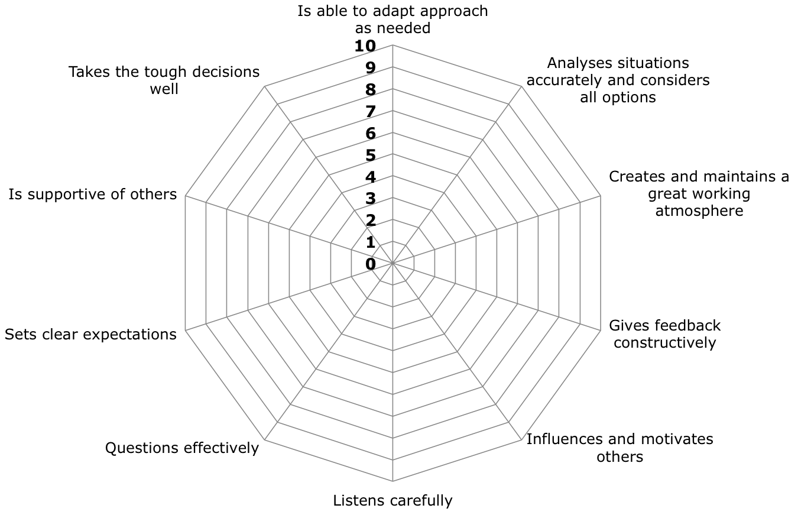Manager Feedback Wheel

Manager Feedback

You have been asked to complete this form to give honest feedback to enable your colleague to develop their skills as a manager.

Please can you consider each of these areas in turn and rate the manager out of 10 for their abilities in each of the following areas.

Please be as honest as you can as this information will give valuable insight to them by enabling them to understand how they are perceived and the most important areas they need to develop into the best manager possible.

|  |  |
| --- | --- |
|  | **Score**  **(1-10)** |
| Is able to adapt approach as needed. |  |
| Analyses situations accurately and considers all options. |  |
| Creates and maintains a great working atmosphere. |  |
| Gives feedback constructively. |  |
| Influences and motivates others. |  |
| Listens carefully. |  |
| Questions effectively. |  |
| Sets clear expectations. |  |
| Is supportive of others. |  |
| Takes the tough decisions well. |  |

Manager Feedback Wheel

# Manager Self Assessment

Action Plan

| Development Needs | Goal | Action to be Taken | Support Needed |
| --- | --- | --- | --- |
|  |  |  |  |
|  |  |  |  |
|  |  |  |  |
|  |  |  |  |
|  |  |  |  |

Action Plan

This is your opportunity to reflect on what you have learnt and identify the actions you will take as a result.

| My Goal | What specific actions do I need to take to achieve this goal? | When will I complete these? | What additional support do I need? | How am I doing? Use this space to monitor progress. |
| --- | --- | --- | --- | --- |
|  |  |  |  |  |
|  |  |  |
| How will I know I have achieved my goal? |
|  |  |  |  |
|  |  |  |